

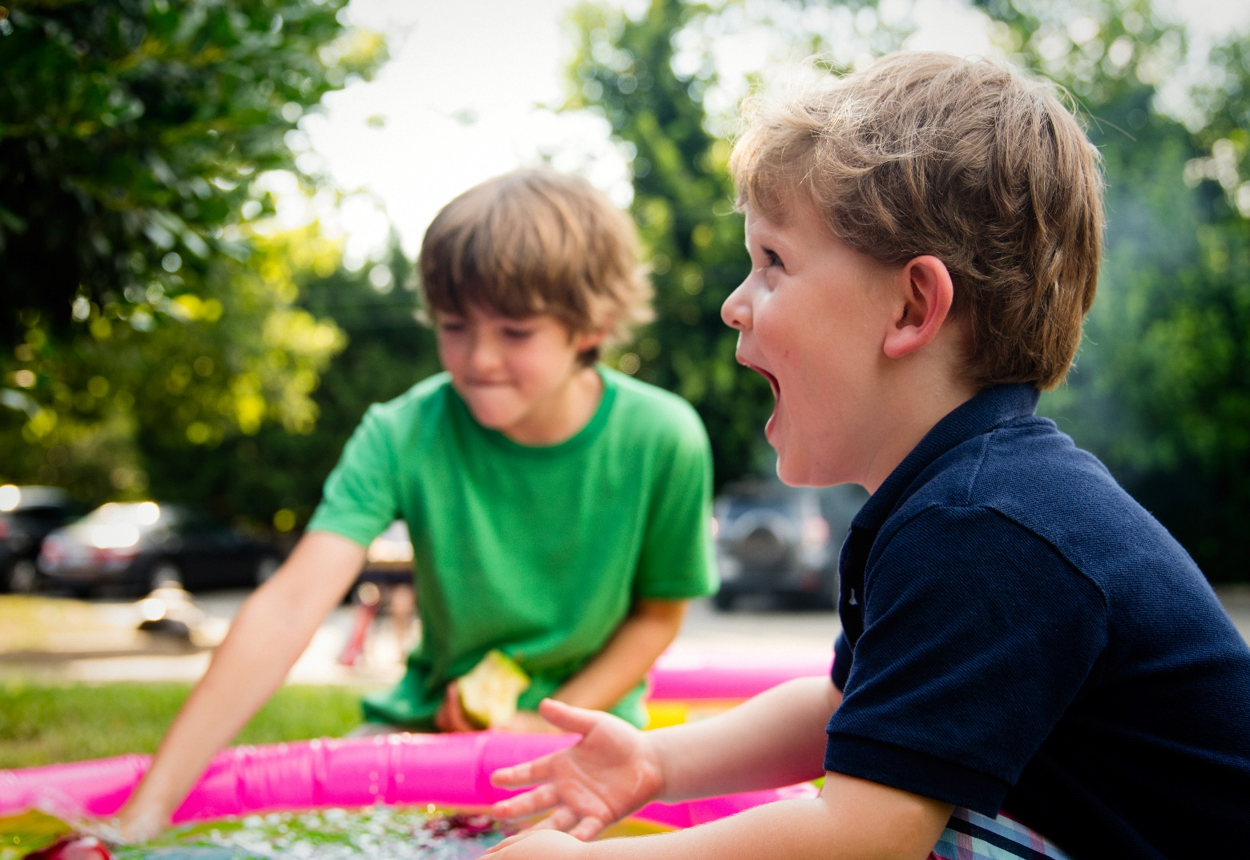**Worshipping Outside**

**Ideas for Schools and Parishes**

**What an opportunity**

As schools and churches continue to adapt to the changing restrictions associated with the pandemic, learning and worshipping outdoors has become increasingly common. As we move through 2021, whole school, orlarge group collective worship is still notpossible. Worship continues to be inbubbles.Schools are organising their worship in a variety of ways. It is hoped that these times of different collective worship may turn out to be high spots of your day together.

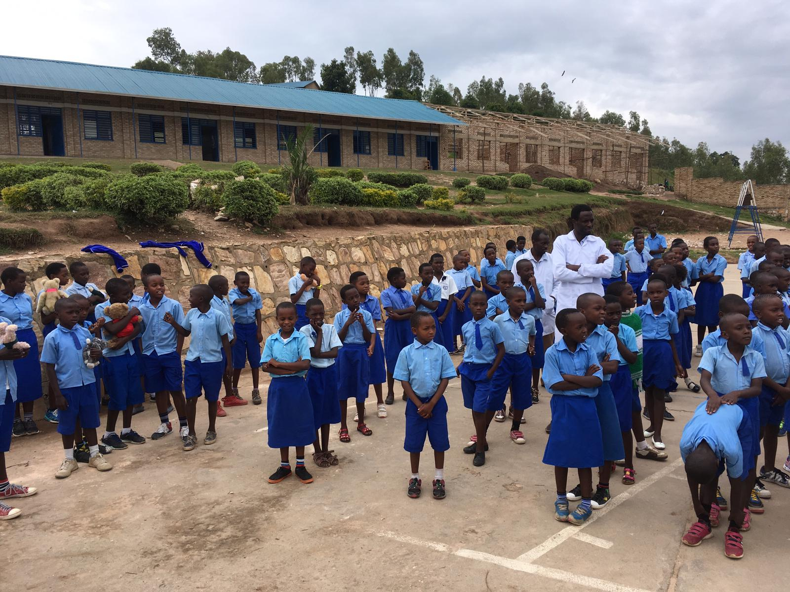Time outdoors has always been healthy, but that’s especially the case now: One study found that [the odds](https://www.nytimes.com/2020/07/03/well/live/coronavirus-spread-outdoors-party.html) of catching Coronavirus are nearly20 times higher indoors than outdoors. Outdoor school has been tried during past epidemics: In the early 1900s, during a tuberculosis outbreak in Americas, children attended a school with the windows always open, even in the freezing winter. They sat in sleeping-bag-like blankets and had heated soapstones placed at their feet. Of course, many places in less-developed countries have rudimentary classrooms that are outdoors and they enjoy daily collective worship outside as a matter of course. The picture shows children in Winchester Diocese’ link diocese in Rwanda enjoying outdoor worship.

Schools are unique communities: what works for one school will not be right for another. The Diocesan Education Team hope that the advice in this booklet will support schools and parishes in organising creative outdoor worship. The ideas in this booklet can also be used by churches and church groups s please share with your community.

#### **Statement of Entitlement for Collective Worship in Church Schools 2021**

This document (see link below for full document) sets out the expectations of the Church of England Education Office for collective worship in church schools. It includes a section on Growing Faith.

[Collective Worship Statement of Entitlement March 2021](https://www.cofeguildford.org.uk/docs/default-source/making-disciples/nurturing-education/education/collective-worship/210311-collective-worship-soe-final.pdf?sfvrsn=74cc0c32_0)

‘Growing Faith’ promotes a partnership between the three local communities of church, school and household to provide space to talk of faith & spiritual matters or ask challenging questions within and between these three communities.

Three principles exemplify this approach:

*Connected Communities: looking for meaningful community connections in the intersection between church, school and household.

* Encounters with God: encountering faith and belief by engaging in conversations about God as individuals and together.

*Imaginative practices: searching for ‘a new way of being church’ and creating new thinking and new doing in relation to children, young people and households.

The ‘Growing Faith adventure is not part of the SIAMS schedule but the local church should normally expect to be part of a church school partnership that encourages and supports the school in effectively developing the impact of and provision for worship. Families can also expect to be partners in collective worship: involved, informed and enabled to collaborate at home if they wish.

Schools should be aware that The Church of England recently published updated [guidance for collective worship in schools](https://www.churchofengland.org/sites/default/files/2021-05/Collective%20Worship%20Guidance%2018052021.pdf). This is mainly a resource for Church of England schools but one which can be helpful to all schools who want to help their children get the most from this opportunity to pause, reflect, sing and pray.

**Outdoor worship structure**

Most church schools use the following four-part model for constructing collective worship. As this is the format that teachers and children are used to, the examples later in this booklet have been linked to each of the four elements of worship.

**Gathering**

What will help to signal the start of this special time? Lighting a candle? Playing some music?

Do you use a set opening response? e.g. ‘Peace be with you.’ – ‘And also with you.’ How will the children be organised in the worship space? Will they sit in rows/groups/families?

**Engaging**

Something that the children will relate to and will catch their interest.

What will you use to create the ‘sacred space’ and engage pupils with your chosen theme? A picture, video, object, game, drama, story?

The Biblical content (story or verse) How will you tell the story? Reading/acting/ with props or puppets?

The way that the Biblical content is linked back to the pupils’ own lives. If you’re using a story or festival from other religions or cultures, how will this connect with your school’s Christian values?

**Responding** (Reflection/Prayer)

This section ensures that the legal requirements for collective worship are met. This could be reflection

while a picture is displayed, music played, or a candle burns. Or it could be a prayer, read, extemporary, interactive. Always phrase this section so that it is clear that prayer is an invitation. You might also decide to offer both reflection and prayer, which ensures that all children and adults should be able to respond in a way that is comfortable for them.

**Sending**

How will you close the worship? A response, a challenge, a thought, picture Bible verse, question on the screen? Do you have a set closing response? What ‘message’ will pupils take back to class with them? How can you encourage them to re-connect with the theme in their classrooms or other worship during the week?

**Gathering**

* If you just sit in rows and do 'normal' worship outside you'll be missing a great opportunity. This is the time to experiment – sitting or standing in the round or in different groups within the bubble ‘picnic style’.
* The worship space can be as ornate or as simple as time and space allows. A simple wooden cross placed on a tree can be very effective.
* Children can decorate pillowcases with pictures from a Bible story or a Christian value. The pillow cases can be filled and then sewn up to produce personal outdoor worship cushions.
* To reflect Anglican practice that the children are used to, create an outdoor worship table similar to that in the hall.

**Engaging and Responding**

**Go with the seasons of nature.**The church seasons are, in some senses, linked. For example the birth of Christ, the Light of the World, is celebrated just after the winter solstice, so the days have become fractionally longer. Easter, resurrection and rebirth comes as spring gets going. By embracing this children will see how much more tightly bound the church calendar and nature's timings are than they might have previously thought.

* **Gathering outdoor allows schools to worship in more creative, expansive ways.** Make paper kites from plastics bags or crepe paper. These are great for Pentecost if they are made in fiery colours. They are an excellent example illustration of how something you cannot see can make things happen, as the wind pulls the kites. Instructions are available on [www.bigwindkites.com](http://www.bigwindkites.com) Bible readings Exodus 34: 22-23 and Acts 2:1-13
* 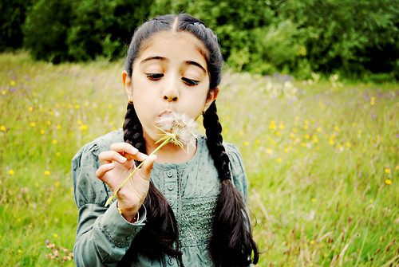**Blow bubbles and as they rise, ask the children to watch them go and pray for God’s Holy Spirt to fill you and take you to where people need you.**
* **Go on a litter pick before worship and use the collected rubbish as a meditation on the need to protect and care for the world.**
* **Pick a dandelion ‘clock’ seedhead and blow the seeds over prepared ground. Dandelions are a very important food source for a wide variety of creatures. As the seeds scatter, send prayers with them for the recreation of our damaged environment.**
* **In summer provide water for children to pour and watch how is sparkles in the sunshine. Ask children to gentle trickle it over their hands as a reminder of Jesus being the light of the world. We may not be the Light, but we can sparkle because of Jesus’ light shining on us.**
* **Provide spades to dig up soil and a container of water. Give children a chance to mix them together to make mud. Ask children to place their hands in the mud and make a handprint on an old sheet as a recognition of each child’s uniqueness.**
* **Give a seed to each child and ask them to cup is carefully in two hands. Ask the children to imagine the seed growing into a tree over the years to come. Ak them to think about the weather that the tree will experience, the animals it will encounter and the happiness of all the people who will see it. Thank God for the sparks of potential squeezed into tiny places and for all the things that we are yet to experience in our own lives. Bible readings Matthew 6:11, John 6:35**
* **Form sticks into a circle and put some food inside. The food would not be for humans but rather food found in the natural environment that another creature might enjoy. You can make a representation of food if you cannot find the real thing. Ask the children to guess which of God’s creatures will come to this table? Talk about how amazing that in all our different** ways, we are all able to be fed. Give thanks that God feeds us. Bible reading Matthew 6: 25-34
* Cut open an apple and tell children that they are the very first people to see inside. Shoe the children that if you cut across it, you will see a tiny star inside. This can start a worship o appreciating the beauty of hidden things, including the beauty inside us that we don’t always see. Bible reference: Proverbs 7:2 and Matthew 12:33
* **Ask some children to climb onto a step or log and jump off pretending to flap their ‘wings’. Ask them if they notice the feeling of freedom. That is how birds feel. Ask them to think that for Christians this feeling may illustrate a feeling of God being inside you. Prayer is not only felt in words.**
* Ask he children to lie on their back and look out for birds. Ask them to notice the different types. Some fly solo, some in pairs or groups. Ask the children to think about what kind of bird they are. Use his to illustrates differences in the natural world and that this can help us to celebrate our own differences. God calls us to be ourselves.
* **Use silences far more**. **Listen and watch for the presence of God in the world around you.**

**Sending**

Above are just some ideas of how outside worship can lend itself to more practical ways of worshipping and offering prayer in our schools. However, it remains important to include the vital element of ‘sending’ in order that the children reflect on the messages of worship in the days and weeks that follow.

Of course the form of this will depend on the message. The most effective messages are ones where the children are sent away with something physical – a stone, a card. A twig etc. to remind them of the worship message. These messages should be revisited in following worship sessions.

The Church of England has a programme of digital recording of its burial grounds, the National Burial Grounds Survey. A map is being compiled showing the location and boundary of every Anglican burial ground, waiting to be filled in with detail. See the links below for more information, and to find out how to research and tell the stories of your community.

<https://www.churchofengland.org/more/church-resources/churchcare/churchcare-news/national-burial-ground-survey-leeds-diocese>

<http://www.debs.ac.uk/>

<https://www.atlanticgeomatics.co.uk/burial-ground-management-system>

The Commonwealth War Graves Commission website; <https://www.cwgc.org/>

**A blessing on the beach**

For those schools who are near the coast or are Beach Schools, the following can be used in a specific beach worship.

**A reading from the book Genesis (1, 20-22)**

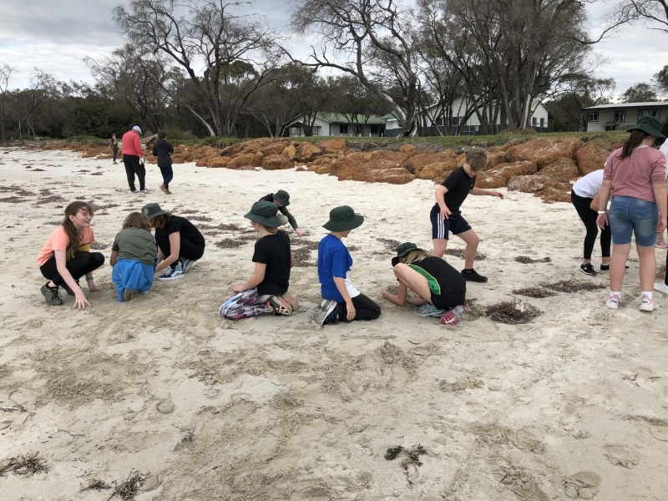God said, ‘Let the waters teem with countless living creatures, and let birds fly above

the earth across the vault of heaven.’ God then created the great sea-monsters and

all living creatures that move and swarm in the waters, according to their kind, and

every kind of bird; and God saw that it was good. So he blessed them and said, ‘Be

fruitful and increase, fill the waters of the seas; and let the birds increase on land.’

**Hymn**

I, the Lord of sea and sky

**‘Take three for the sea’**

This movement is built on the simple principle of everyone who visits the sea or a waterway picking up and taking home three pieces of rubbish to throw away appropriately.

Create sand or stone sculptures during worship, working alone or in small groups. Enjoy wandering around them as a kind of art gallery, enjoying human creativity and life in all its fullness.

Read the poem The Other by RS Thomas. As you listen to the waves, think about what prayers you can offer to God? What prayers from other people around the world are you joining up with today?

Use the story of the leaves and the fishes to illustrate generosity.

Alternatively, use the reading below:

**A reading from the Gospel according to**

**John (21, 9-13)**

When the disciples came ashore, they saw a charcoal fire there, with fish laid on it

and some bread. Jesus said, ‘Bring some of your catch.’ Simon Peter went aboard

and dragged the net to land, full of

big fish. A hundred and fifty three of them; and

yet, many as they were, the net was not torn. Jesus said, ‘Come and have

breakfast.’ None of the disciples dared to ask, ‘Who are you?’ They knew it was the

Lord. Jesus now came up, took the bread, and gave it to them, and the fish in the same way**.**

**The Blessing**

Blessed are you, maker of the wide immeasurable sea and all living

things, both great and small; bless all the fish and creatures in the sea, that

their shimmering beauty may not be lost on us. Through Jesus Christ, who called his

own disciples to eat together on the beach. Amen.

**Forest Schools**

Many diocesan schools have signed up to be Forest Schools. Forest school is an outdoor education delivery model in which children visit natural spaces to learn personal, social and technical skills. It has been defined as "an inspirational process that offers children, young people and adults regular opportunities to achieve and develop confidence through hands-on learning in a woodland environment" and as such can also help children to develop spiritually.

<https://www.forestschools.com>

**A forest-based worship activity**

This is a nice worship to calm children at the start of a new busy school year.

Take a moment for a simple opening ritual. You may choose to gather children in smaller groups on a blanket, or hold hands around a tree.

Welcome everyone and say hello to nature. Look up, look down, breathe in, breathe out.

You might like to say forest school rhyme like this one –

***Welcome to God’s forest,*  
*to the plants and the trees.*  
*Welcome to the birds,*  
*to the beetles and the bees.*  
*Welcome me and welcome you,*  
*to our outdoor reflection space.*  
*All are welcome and have a home*  
*in this special nature space.***

You may choose to read a simple extract from the Creation Story – noting the care and work of God. Explain to the children that this worship activity will be quiet and thoughtful. It will allow them a chance to stop and think about the wonder of Creation.

A simple way to introduce this to children is with a sit spot activity.

A sit spot is a place to stop and sit, somewhere you can pause a while. Anywhere can be a sit spot: a log, leaning on a tree trunk, sitting at the base of a tree, a place along a riverbank, a bench in a park, or a corner of a meadow.

Ask the children to mentally choose their own special sit spot in the school grounds, somewhere they can see from where they are.

Model what the children are going to do in their it Spot to appreciate the beauty of God’s world.

**Sit down, get comfortable, and wait.**

**Intentionally draw your attention to what you can see, what you can hear, what you can feel, what you can smell.**

**Look down. Look up.**

**Close your eyes for a while, then open them.**

**Breathe in deep and release your breath. Let your breathing patterns rise and fall naturally.**

Think about the wonderful world around you. Tell the children that they may quietly thank God for the beauty that they can see, feel, smell and hear. The more time you spend in your sit spot, the more you will notice about your surroundings.

Invite your children to select their own special sit spot, somewhere that’s appealing to them and tap each child on the shoulder to send them to their Sit Spot, telling them that you ill collect them when it is time to gather together again.

**Closing prayer**

Father God, as we look forward to the coming year, we ask that you will bless us and be close to us.

Lord, in the year that’s about to start, Help us to love you with all our hearts.

Help us all to make the most of all the opportunities and beauty in the beautiful world you have given to us.

Give us the strength and courage to deal with any difficulties and disappointments of the coming year.

In everything we do this year, may we turn to you for help and guidance.

Lord, in the year that’s about to start; Help us to love you with all our hearts. Amen

**Prayers**

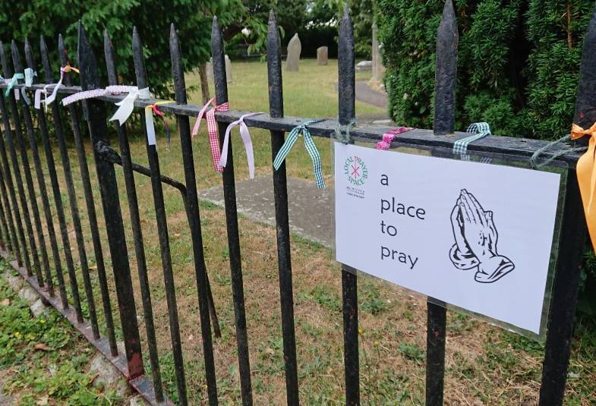The Diocese of Salisbury has developed local prayer spaces by setting aside some outside space adorned with beautiful signs, to visibly encourage those who are looking for a place to pray.

Giving the school community the invitation to ponder and pray is a simple gift for us to share” says Rt. Revd Karen Gorham, Bishop of Sherborne.

Churches and schools are encouraged to create a sign and place it close to a bench, a space overlooking a stream, near a footpath or where there is a view or a place to sit – to remind people of God’s peace and presence and invite them to pray. These cards can be used in the school grounds and around the parish.

This world  
Your creation  
Rolled Into a sphere  
Packaged in sunshine  
Gift-wrapped in love  
Given to us  
Thank you. Amen

Creator God  
who breathed this world into being,  
who can be felt within   
the harmony of nature,   
the perfection of a butterfly's wing,  
the grandeur of a mountain range,  
the soaring eagle and humming bird,  
thank you for this world  
which you have created.  
Thank you for summer sun,  
which reminds us   
that your creative breath   
is still alive and active.   
Thank you for the warmth of your love,   
sustaining this world,  
your garden.

Amen

There are many more ideas for worship and prayerful activities in the Diocesan Education Team’s booklet **TenTen#Flourishing** available on the diocesan websites.

[**https://www.winchester.anglican.org**](https://www.winchester.anglican.org)

[**https://www.portsmouth.anglican.org/**](https://www.portsmouth.anglican.org/)

A link to the Prayer Spaces in Schools website is below

[https://**prayerspaces**in**schools**.com](https://prayerspacesinschools.com)